**BUILDING/ZONING**

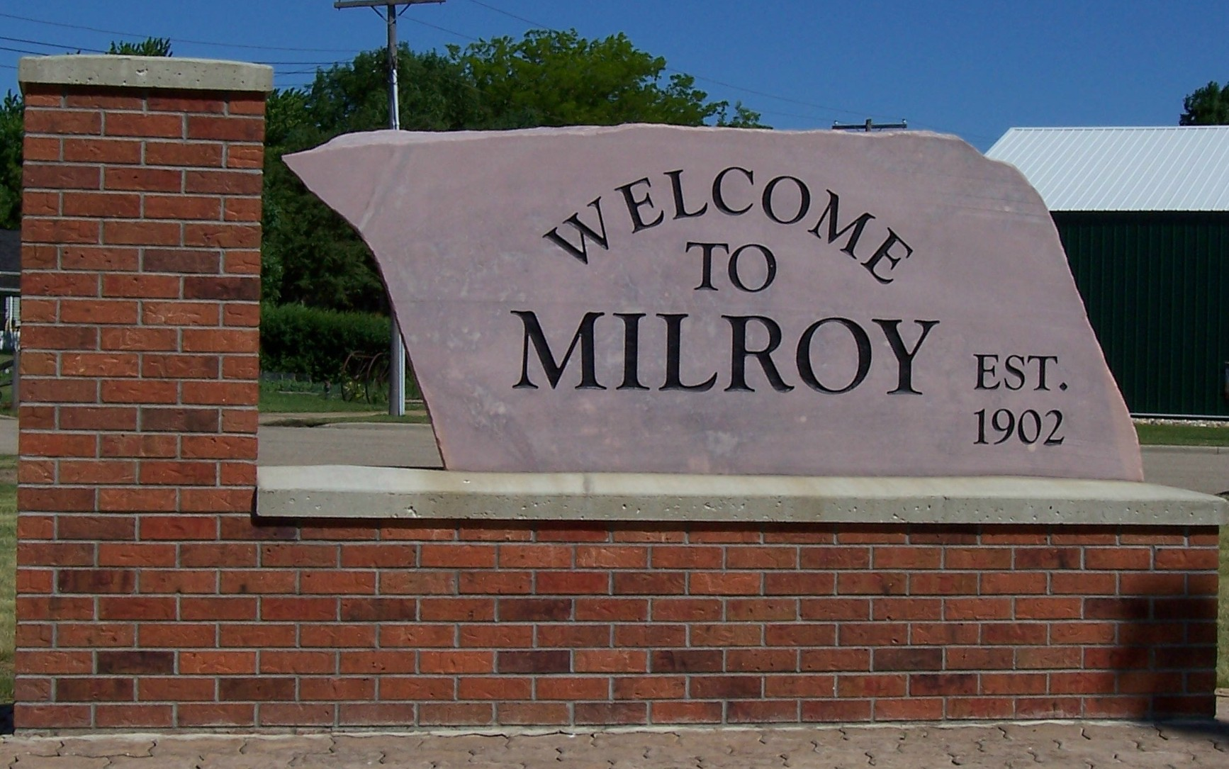

**PERMIT APPLICATION**

Office of Clerk/Treasurer • 410 Euclid Avenue • PO Box 9 • Milroy, MN 56263 • (507) 336-2495

Property Owner:

Mailing Address: Phone:

City, State Zip: Email:

**PROPERTY INFORMATION**



Property Address:

Parcel Number:

Property Type:

Residential

Commercial

Industrial

**PROJECT INFORMATION**

|  |  |
| --- | --- |
| ____New Residential/Commercial Structure ($500.00)  **____**Utility Shed – 320Sq. Ft. or Less ($25.00)  ____Accessory Structure ($100.00)  ____Accessory shed larger than 320 Sq. Ft. ($100.00)  ____Addition onto an existing Residential/Commercial  Structure ($150.00)  ____Deck/Patio/Fence/Concrete ($25.00)  ____Step Replacement larger than 36 Sq. Ft. ($10.00) | Dimensions of Project:  Length: Width:    Height: Area: |
| Project Description:  **_________________________________________________________________________________________________________________________________**  _________________________________________________________________________________________________________________________________ | |

**All Building/Zoning Permit Applications must include a detailed site plan drawn to scale.**

**OWNER STATEMENT**

I hereby apply for a building/zoning permit, and I acknowledge that the information provided above and on the submitted site plan is complete and accurate and that all work will be in conformance with the approved plan and codes, covenants & ordinances of the City of Milroy.

I understand that this is a permit application and work is not to start without a permit.

Owner Signature: _________________________________________________________ Date: ___________________________

**This Application has been Reviewed and Approved by:**

Public Works Supervisor Building/Zoning Administrator

Received: __________________________________

Date Approved: ____________________________

Permit Number: ____________________________

**Application for Building/Zoning Permit**

Applications for a Building/Zoning Permit shall be made to the City Clerk together with the required fee(s)

# FILING/PROCESS INSTRUCTIONS

The application must be fully completed with true and correct information. The property owners’ signature is required for all

applications. I, the owner, agree to pay the required fee for this application at time of request and understand that this request be refused,

the fee will not be returned. I also understand that should this request be granted; all work shall be done within 1 (one) year from date of

approval and all materials shall follow the plans and specifications submitted and property taxes will be current with all the Ordinances

of the city. Incomplete applications or applications with insufficient information will delay the processing.

Applications shall be submitted to:

|  |
| --- |
| City of Milroy |
| 410 Euclid Avenue |
| PO Box 9 |
| Milroy, MN 56263 |

**GOPHER STATE ONE CALL**

**1-800-252-1166**

CALL BEFORE YOU DIG… IT’S THE LAW

QUESTION THEY WILL ASK:

•STREET ADDRESS

•TYPE OF WORK TO BE DONE

•WILL YOU BE USING EXPLOSIVES

•NEAREST INTERSECTING STREET

•HOW LONG WILL THE DIGGING TAKE PLACE

•WHEN WILL THE WORK BEGIN

•LOCATION OF WORK (ex: REAR HALF OF LOT OR AREA MARKED BY WHITE STAKES, ETC)

•CONTACT NAME AND PHONE NUMBER

YOU WILL ALSO NEED TO GIVE THE POWER, CABLE, PHONE AND MUNICIPAL UTILITY COMPANIES ENOUGH TIME TO LOCATE THESE ITEMS. GOPHER STATE ONE CALL WILL NOT ALLOW DIGGING FOR AT LEAST TWO (2) WORKING DAYS AFTER YOU CALL IN.

TRY TO CALL AT LEAST SEVEN (7) DAYS BEFORE YOU PLAN TO DIG.