**BUILDING/ZONING**

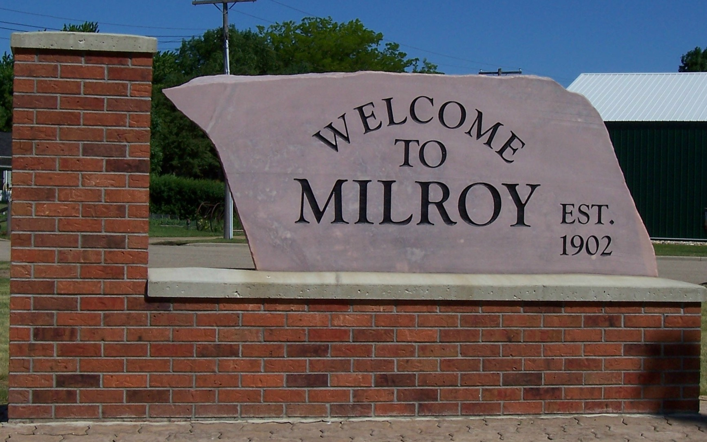

**SPECAIL REQUEST APPLICATION**

Office of Clerk/Treasurer • 410 Euclid Avenue • PO Box 9 • Milroy, MN 56263 • (507) 336-2495

Property Owner:

Mailing Address: Phone:

City, State Zip: Email:

**PROPERTY INFORMATION**



Property Address:

Parcel Number:

Property Type:

Residential

Commercial

Industrial

**PROJECT INFORMATION**

|  |  |
| --- | --- |
| ____Rezoning ($200.00)  **____**Conditional Use Permit ($300.00)  ____Variance ($300.00)  ____Adult Use Business ($5,000.00) | Dimensions of Project:  Length: Width:    Height: Area: |
| Reason for Special Request:  ____________________________________________________________________________________________________________________  ____________________________________________________________________________________________________________________   1. Will the proposed change be suitable so as not to create excessive burden on existing parks, schools, streets, parking   supply, and other public facilities which serve or are proposed to serve the area? Yes: ___ No: ____  Please explain: __________________________________________________________________________________________________   1. Will the proposed change be sufficiently compatible or separated by distance or screening from adjacent residentially   zoned or used property? Yes: ___ No: ___    Please explain: __________________________________________________________________________________________________   1. Please describe the proposed use of the property: ______________________________________________________________________________________________________________ 2. Does the site have adequate utilities, access roads, drainage and necessary infra-structure facilities?   Yes: ____ No: _____ | |

**OWNER STATEMENT**

I, the owner, agree to pay the required fee for this special application at time of request and understand that this request be refused, the fee will not be returned. I also understand that should this request be granted, application for a building/zoning permit will be made following the ordinances of the City of Milroy.

I understand that this is a permit application and work is not to start without a permit.

Owner Signature: Date:

# FILING INSTRUCTIONS

The application must be fully completed with true and correct information. The property owners’ signature is required for all applications. Incomplete applications or applications with insufficient information will delay the processing. Applications shall be submitted to:

|  |
| --- |
| City of Milroy |
| 410 Euclid Avenue |
| PO Box 9 |
| Milroy, MN 56263 |