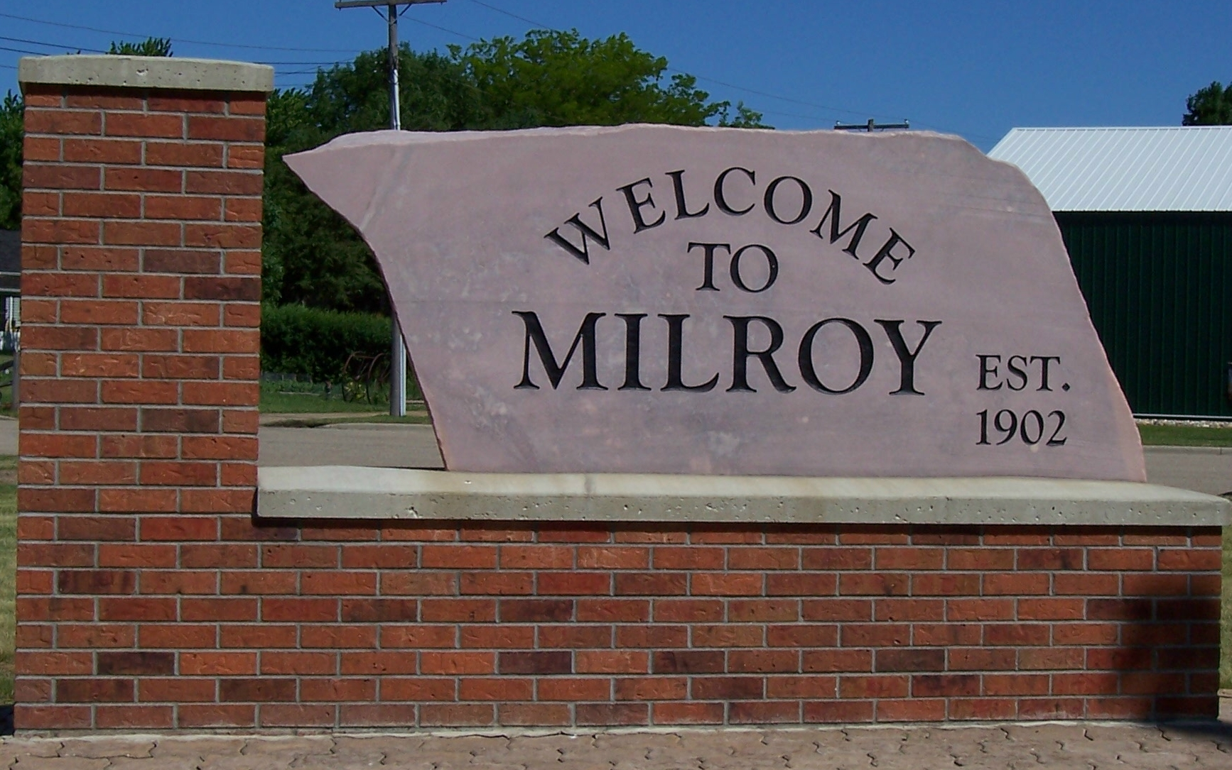

OPEN FORUM COMMENT FORM AND GUIDELINES
The Milroy City Council welcomes ideas or comments from the public during its Open Forum section of the meeting. The Open Forum is for comments about issues NOT ON THE AGENDA.
- Please fill out this form and present it to the City Clerk BEFORE THE MEETING BEGINS. Your name, address and a summary of your comments will be included in the city council meeting minutes. This original form will become part of the permanent record, as part of the council agenda packet.
- The mayor will call on you when it’s your turn to speak. Before you begin your comments, please say your name and address for the public record.
- You will be given a reasonable amount of time to address the Council, at the discretion of the mayor. If there are multiple people present to speak during the Open Forum, you may be limited to 3 minutes.
- The mayor will end any presentation which either is or becomes redundant, irrelevant, or disrespectful to the Council, city staff or other residents.
- Items brought forward during Open Forum will not be acted upon during the current council meeting. The Council may direct staff to place an item for consideration at a future council meeting.
- Please summarize your comments in the space below:
___________________________________________________________________________ ___________________________________________________________________________
___________________________________________________________________________
___________________________________________________________________________
Name: _______________________________ Phone: _____________________________
Address: ______________________________ Email: ______________________________
______________________________________

