**CITY OF MILROY**

410 Euclid Ave • PO Box 9 • Milroy, MN 56263

Phone: (507)-336-2495 • E-mail: [milroy@mnval.net](mailto:milroy@mnval.net) • Website: [www.milroy.municipalimpact.com](http://www.milroy.municipalimpact.com)

I (we) authorize the City of Milroy to initiate debit/credit entries for payment of my (our) account on the due date, and to initiate, if necessary, adjustments for any debit/credit entries in error to my (our) account. I (we) also authorize the banking facility indicated to debit and/or credit the same to such an account. I (we) understand that upon receipt of a draft returned to the City of Milroy due to insufficient funds in my (our) account, the City of Milroy may cancel drafting of my utility bill and charge applicable fees ($35.00). There will also be a charge of $.50 per month which will be listed on your utility bill.

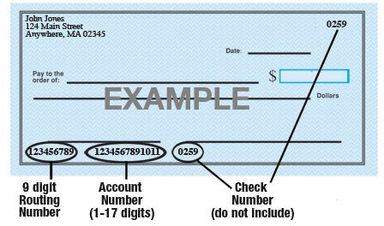



Type of Account:

Checking

Savings

Bank Name:

Phone #:

Bank Address:

Routing #:

Account #:

*\*\* Please attach a voided check or copy of a check for verification of account.*

I (we) understand that this authorization will remain in full force and effect until I (we) notify the City of Milroy in writing that I (we) wish to revoke this authorization. If you wish to stop the automatic drafting of your account or if you have changes in utility account number, bank name, bank account or bank routing number, please notify the City of Milroy at once by calling (507) 336-2495 and follow-up with written notification. I (we) also understand that the City of Milroy requires at least three (3) days prior notice to cancel this authorization.

Name: Utility Account #:

Signature: Date: